HERITAGE TREASURE:
AN IN-DEPTH ANALYSIS OF UNSESCO WORLD HERITAGE SITES IN TABLEAU
Submitted in partial fulfilment of the requirments for the degree of
BACHELOR OF BUSINESS
ADMINISTRATION
By
P. MOHAN BALAJI
(24B91M0035)


SAGI RAMAKRISHNAM RAJU ENGINEERING COLLEGE, BHIMAVARAM
2026-2027

1. Introduction:
Data visualization is an essential part of Business Intelligence (BI), enabling users to transform raw data into meaningful insights through interactive charts and dashboards. Tableau is one of the leading BI tools used for creating dynamic visualizations without requiring advanced programming skills.
In this project, Tableau is used to analyze the UNESCO World Heritage Sites dataset (2019). The project focuses on understanding the global distribution of heritage sites, identifying endangered sites, analyzing inscription trends over the years, and comparing heritage categories across different countries and regions. The final output includes interactive dashboards, stories, and filters that make the data easy to understand.
2. Dataset Description:
- Dataset Name
- UNESCO World Heritage Sites (2019)
- Dataset Source
- Kaggle
- Dataset Format
- CSV (Comma Separated Values)
- Description
The dataset contains information about UNESCO World Heritage Sites recognized for their cultural, natural, and mixed heritage value. Each record represents one heritage site and includes information such as country, region, category, danger status, and inscription year. The dataset serves as the foundation for creating interactive dashboards in Tableau.
3. Dataset Columns:
- Column Name
- Description
- Name_en
- Name of the Heritage Site
- Country
- Country where the site is located
- Region
- UNESCO Region
- Category
- Cultural, Natural, or Mixed
- Danger
- Indicates whether the site is in danger
- Date_inscribed
- Year when the site was inscribed
- Latitude
- Geographic Latitude
- Longitude
- Geographic Longitude
4. Data Collection:
The UNESCO World Heritage Sites dataset was downloaded from Kaggle in CSV format. After downloading, the dataset was verified in Microsoft Excel to ensure all records were complete and properly formatted. The CSV file was then imported into Tableau Public for analysis.
Steps:
- Download dataset from Kaggle.
- Extract the ZIP file.
- Open the CSV file in Excel.
- Verify column names and data.
- Save the file.
- Import the CSV into Tableau Public.
5. Connecting Dataset with Tableau:
The dataset was connected to Tableau Public using the Text File connection.
Steps:
- Open Tableau Public.
- Click Connect → Text File.
- Browse to the UNESCO CSV dataset.
- Select the dataset.
- Verify that all fields are correctly recognized.
After successful loading, Tableau automatically categorized fields as Dimensions and Measures, making them ready for visualization.
6. Data Preprocessing:
Before creating visualizations, the dataset was cleaned and prepared.
The following preprocessing steps were performed:
- Checked for missing values.
- Removed duplicate records.
- Verified country names.
- Converted the inscription year to Date format.
- Verified latitude and longitude values.
- Removed unnecessary columns.
- Checked data consistency.
Data preprocessing improved the quality and accuracy of the visualizations.
Dataset Link:
"Data Source: UNESCO World Heritage Dataset (Kaggle)"
https://www.kaggle.com/datasets/thedevastator/unesco-world-heritage-sites-dataset

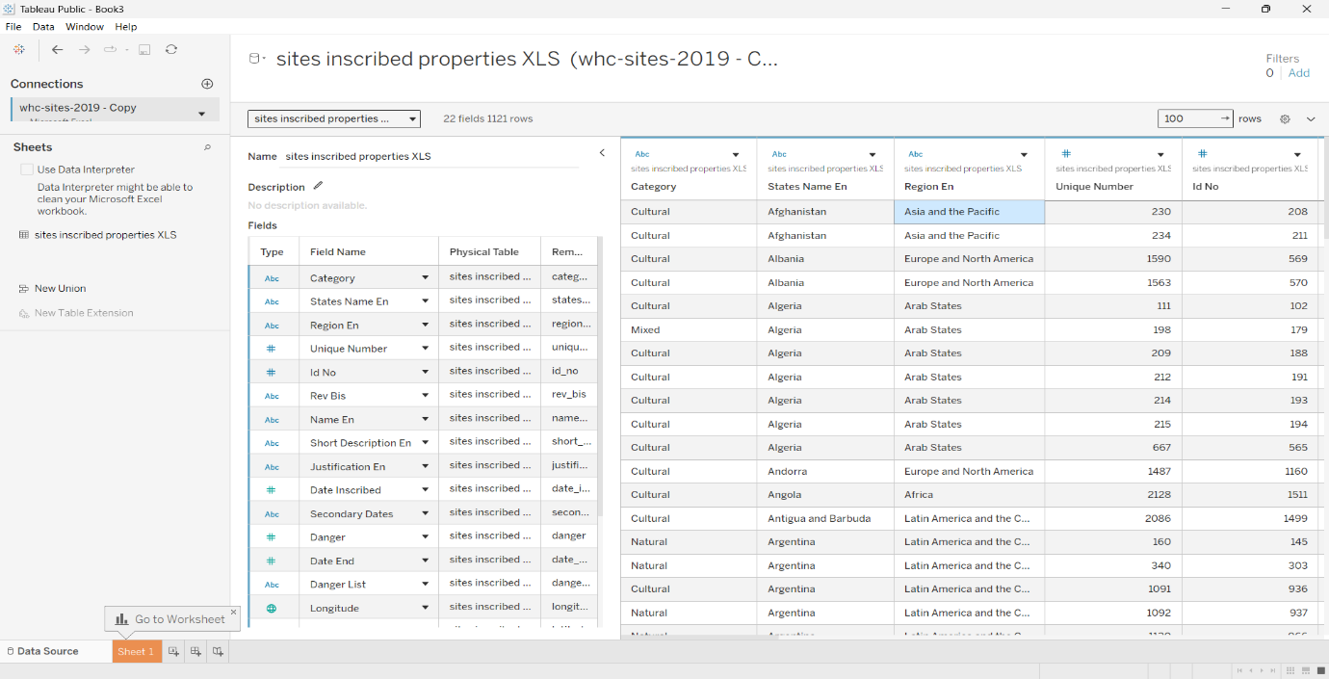
Fig.1

7. Business Questions:
The following business questions were identified:

Business Question 1
- Which countries have the highest number of UNESCO World Heritage Sites?

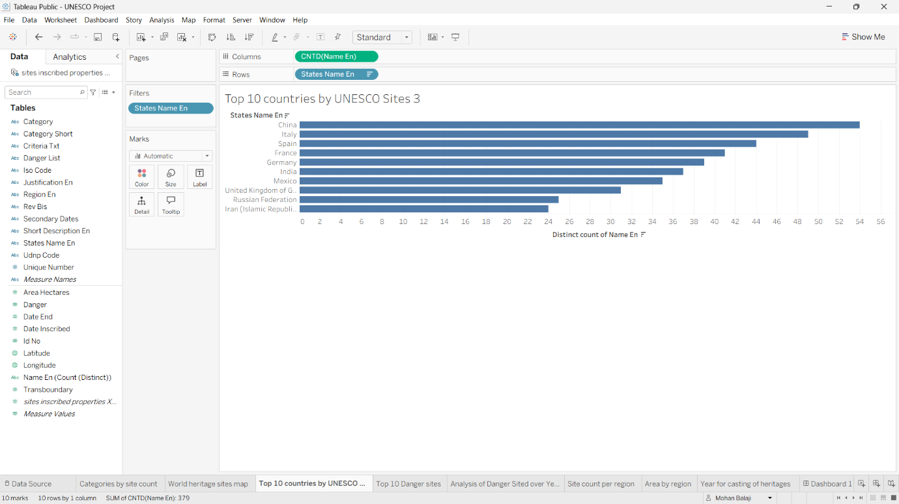
Fig.2
Visualization Used: Bar chart
Purpose: Identify countries with the largest number of heritage sites.

Business Question 2
- How many heritage sites are classified as "In Danger"?

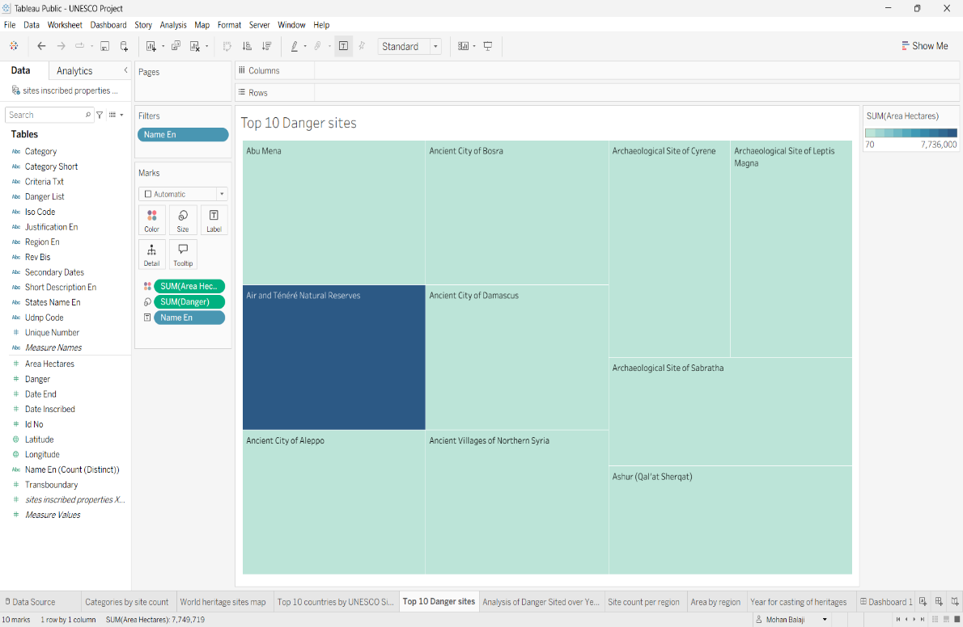
Fig.3
Visualization Used: Treemap
Purpose: Compare endangered and safe heritage sites.

Business Question 3
- How have heritage site inscriptions evolved over the years?

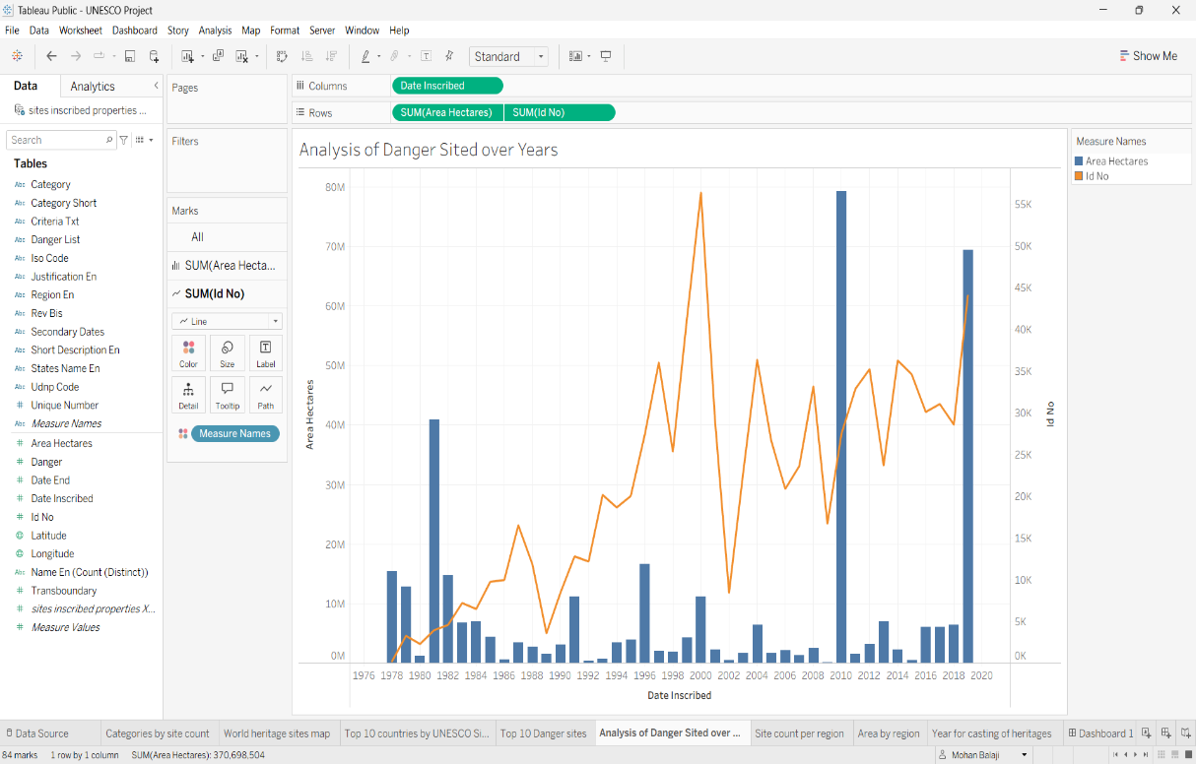
Fig.4
Visualization Used: Area + Line Chart
Purpose: Analyze inscription trends by year.

Business Question 4
- Which UNESCO regions contain the highest number of heritage sites ?

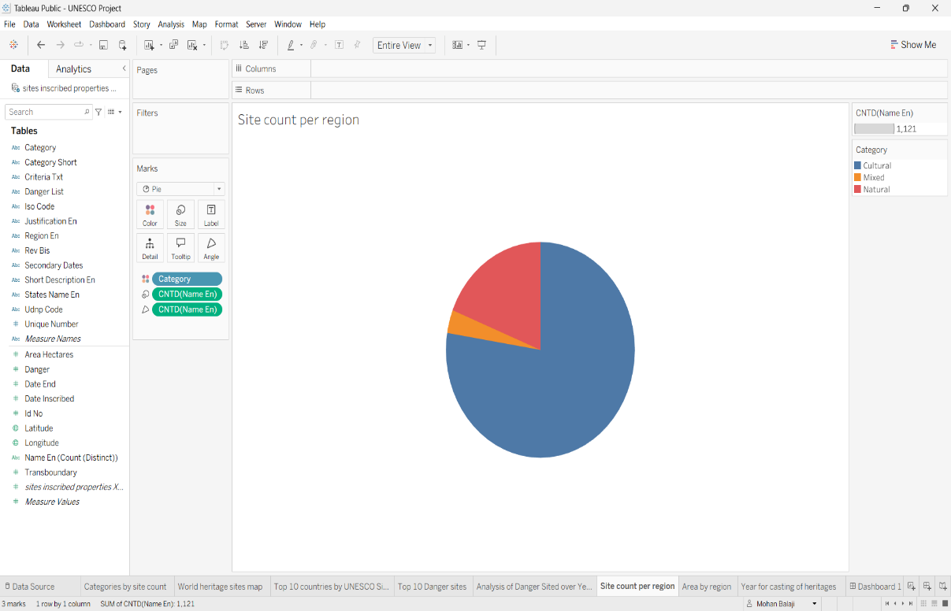
Fig.5
Visualization Used: Pie Chart
Purpose: Compare the distribution of sites across regions.

Business Question 5
- What is the distribution of Cultural, Natural, and Mixed heritage sites?

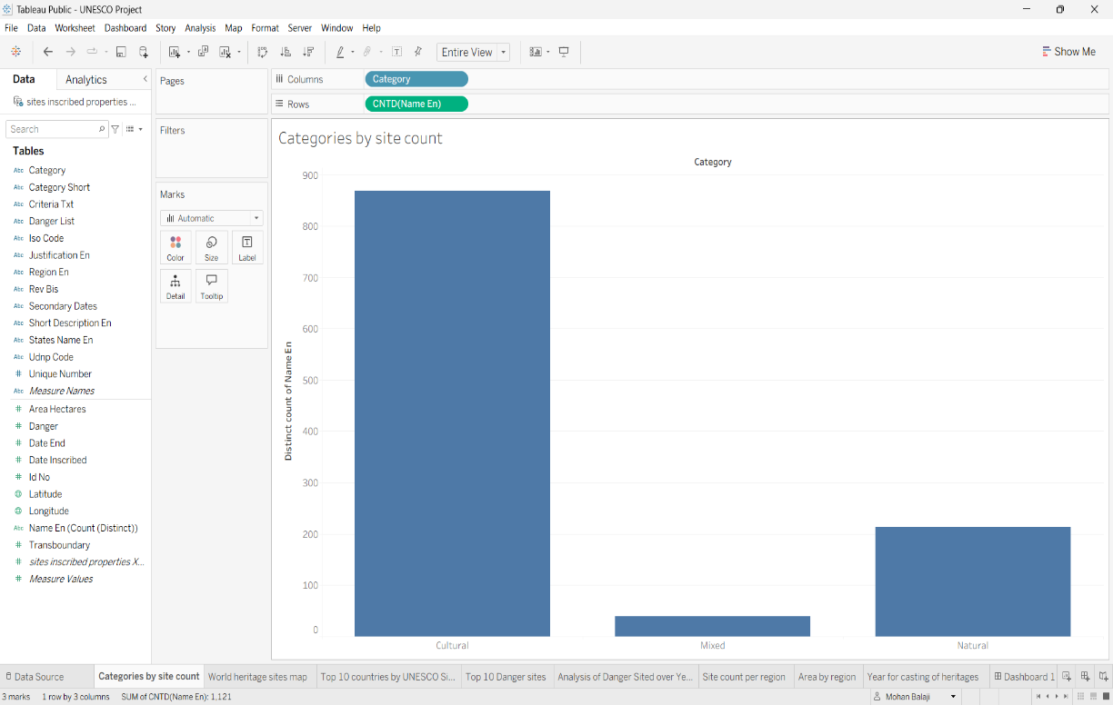
Fig.6
Visualization Used: Stacked Bar Chart
Purpose: Compare heritage categories.

Business Question 6
- Where are UNESCO World Heritage Sites geographically located?

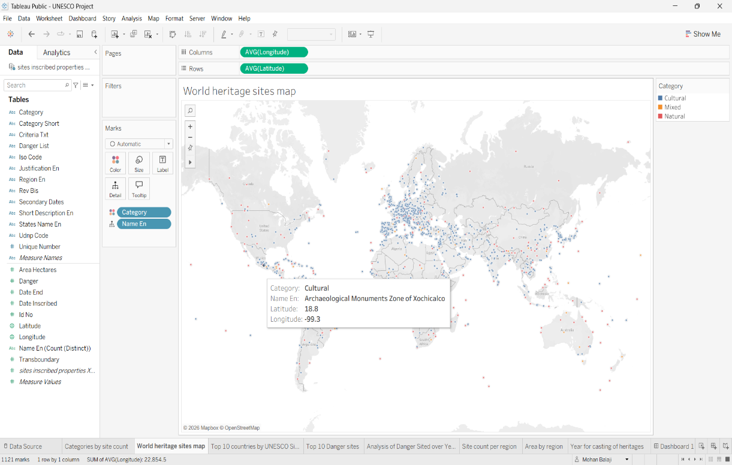
Fig.7
Visualization Used: Map
Purpose: Display global distribution of heritage sites.

Business Question 7
- How does the total heritage site area differ by region?

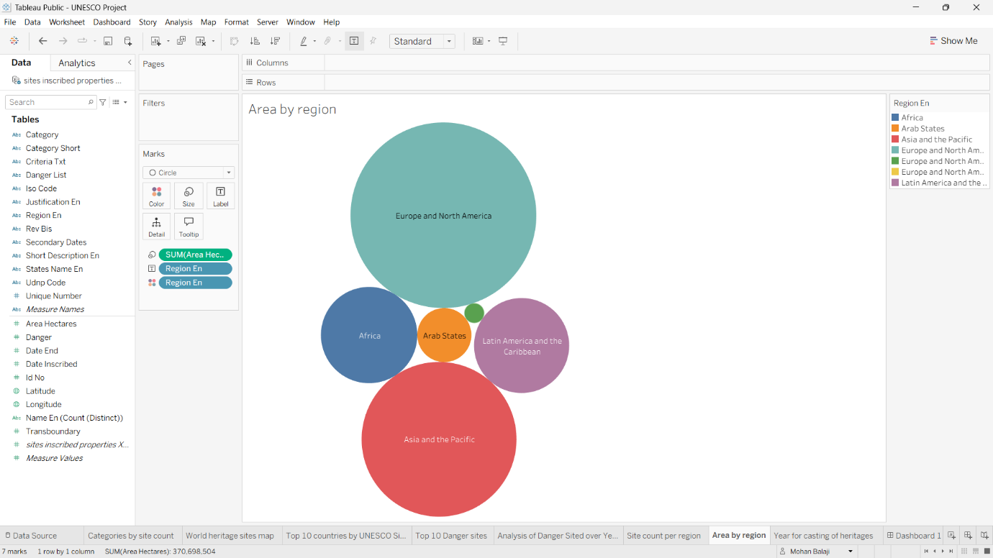
Fig.8
Visualization Used: Bar Chart
Purpose: To measure the land area (in hectares) of heritage sites across regions.

Business Question 8
- How have heritage site inscriptions evolved over the years?

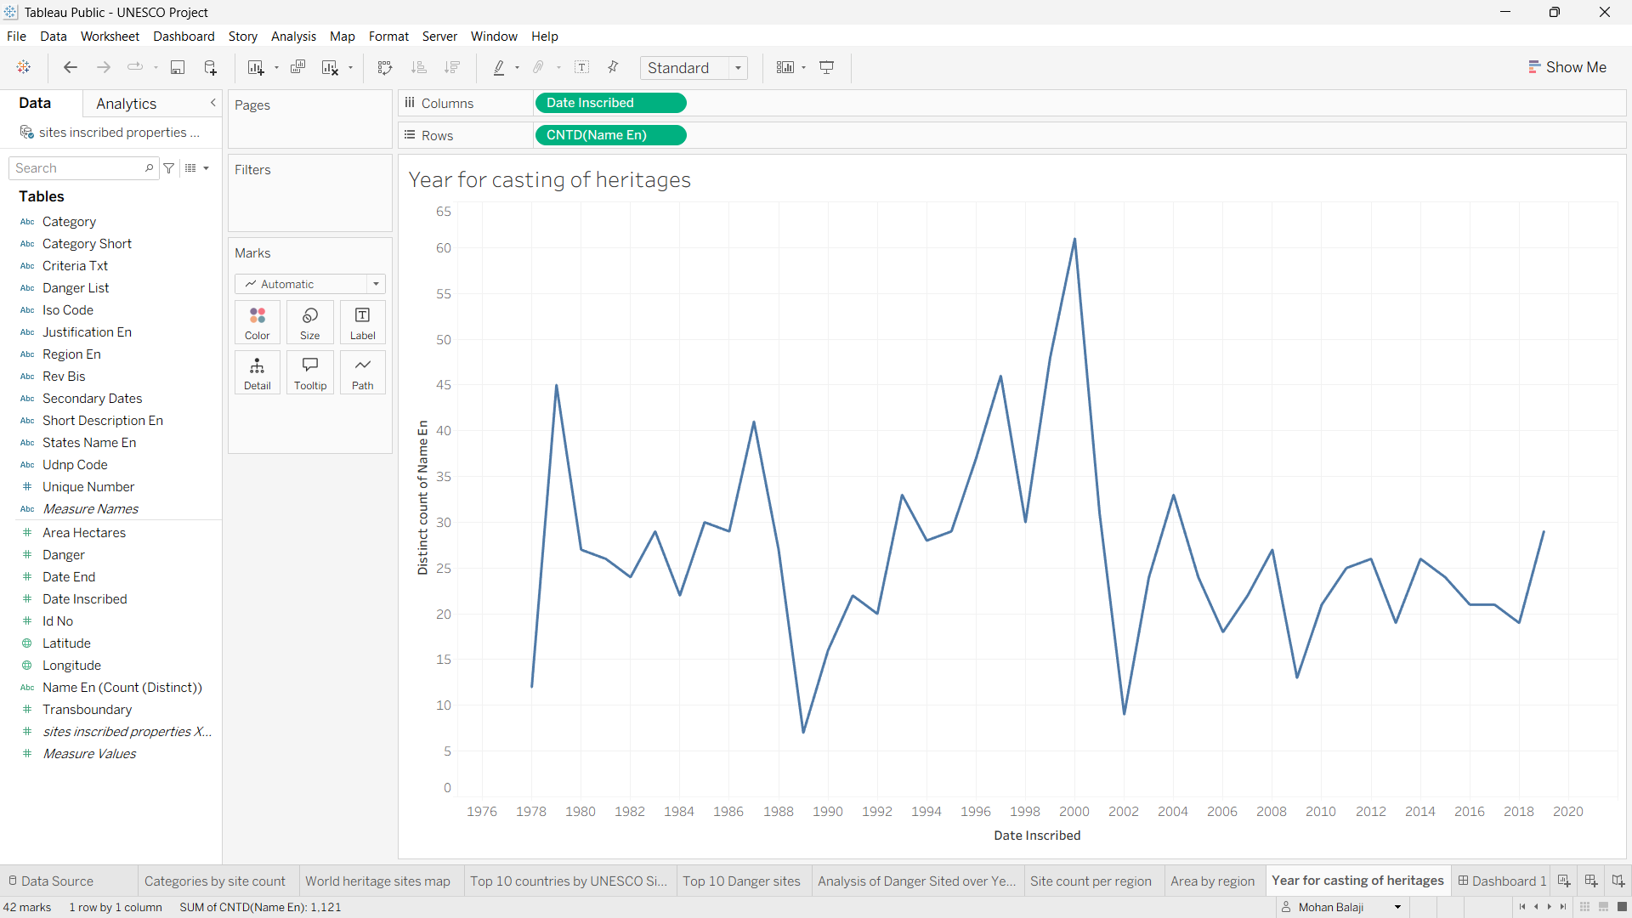
Fig.9
Visualization Used: Map
Purpose: To observe the historical trend of when these heritage sites were officially inscribed.

9. Advantages:
- Easy data interpretation
- Interactive filtering
- Better decision-making
- User-friendly dashboards
- Effective global heritage analysis
10. Summary:
This phase covered the complete project development process, including dataset collection, preprocessing, business question formulation, and creation of interactive Tableau visualizations. These visualizations form the foundation of the dashboard and story developed in the next phase.

